Exam Results Summer 2021

Despite the many challenges this year has thrown at us, our young people have excelled themselves and achieved outstanding results in the summer series examinations.

Given the small number so of learners we have and the acuity of their mental health, these are really incredible results.

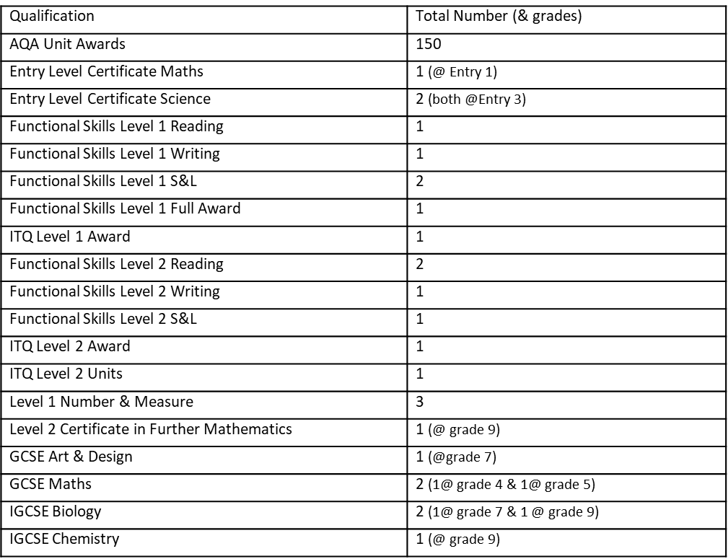Please see the table below for a breakdown of these achievements

Unit Awards Breakdown

